Data Science ̶ Part I

# Explain how to generate in practice samples from a given distribution. You may also discuss the particular cases of the Uniform and Gaussian distributions.

+ TP2

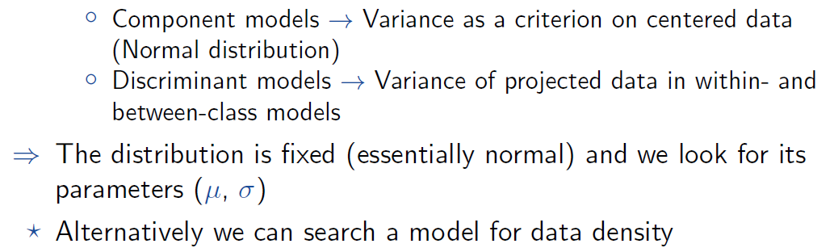

# Explain in detail the method of Principal Component Analysis (PCA) including assumptions, calculation, and interpretation of the technique.

+ TP 3

# When performing Principal Component Analysis (PCA), how should one choose the number of eigenvectors to keep? Explain why and discuss the implication on the reconstruction.

# Explain the method of Factorial Component Analysis (FCA) including assumptions, calculation, and interpretation of the technique. In particular, discuss the specificity of the data it operates on.

+ TP 3

# Explain the method of Linear Discriminant Analysis (LDA) including assumptions, calculation, and interpretation of the technique. How is this technique used for classification?

+ TP 4

# Explain the Gaussian Mixture Model including assumptions, calculation, and interpretation of the model. What are its parameters? Explain how to optimize them given some data.

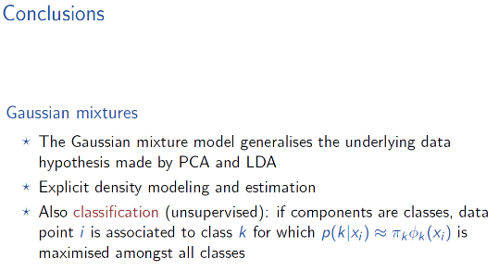



# What is the EM algorithm and how is it related to the Gaussian Mixture Model? In particular, explain the concept of responsibility.

+ EM-part 2 in lecture videos (review)

# Explain the problem of clustering and describe the k-means clustering algorithm. In particular, discuss the function it minimizes and its relation to a Gaussian model.

+ TP 4



# Explain what is the model for temporal data analysis and justify how to characterize and remove seasonality and noise. Discuss the linear prediction models.

+ TP 4



# What is an Auto-regressive prediction model? Explain how to apply it over given temporal data.

+ TP 4